## **ETS IoT KIT**

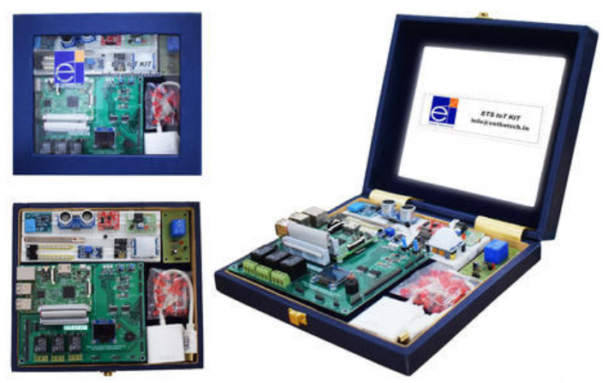

**Specifications**

* Quad-core ARM Cortex-A53 (Armv8-A architecture)
* Up to 1.2GHz Clock speed
* Broadcom Video Core IV
* 1GB LPDDR2 (900 MHz)
* MicroSDHC slot for on-board storage

**Communication Interfaces**

* 10/100 Ethernet
* 2.4GHz 802.11n wireless
* Bluetooth 4.1 Classic
* Bluetooth Low Energy

**On board Sensors**

* Accelerometer
* Gyroscope
* Temperature
* Humidity
* Pressure

**User interfaces**

* 3x3 channel relay
* 3 RGB LED
* 2 Push button
* Buzzer
* OLED display

**Ports**

* UART
* SPI
* I2C
* 8 Analog I/O
* 31 GPIOs to interface external sensors
* 4 USB 2.0 port
* 3.5mm analog audio-video jack
* 5x5V Power supply
* 3x3.3V Power supply
* HDMI output
* Camera Serial Interface(CSI)
* Display Serial Interface(DSI)

**External Accessories**

* Breadboard
* M-M Jumper Wires – 40 No’s
* M-F Jumper Wires – 40 No’s
* F-F Jumper Wires – 40 No’s
* Power Adaptor with USB Cable
* HDMI to VGA Converter
* IR Sensor
* PIR Sensor
* Vibration Sensor
* Magnetic Door Sensor
* Flame Sensor
* DHT11 Sensor
* Ultrasonic Sensor
* LM35+Resistor
* Soil Moisture Sensor
* Rain Sensor
* LDR Module
* GAS Sensor (MQ2)
* Air Quality Sensor (MQ135)
* Servomotor
* Stepper Motor with driver Module